**OUTPUTS**

**EXERCISE - 1**

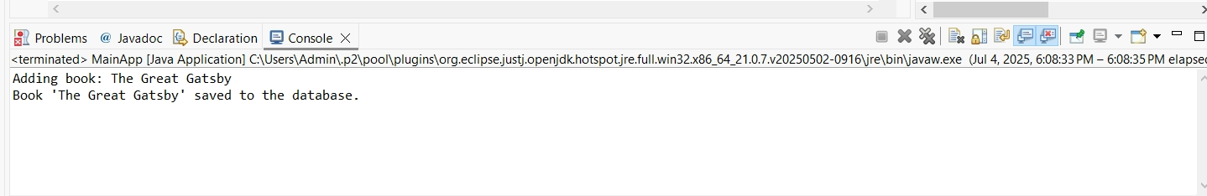

**EXERCISE – 2**

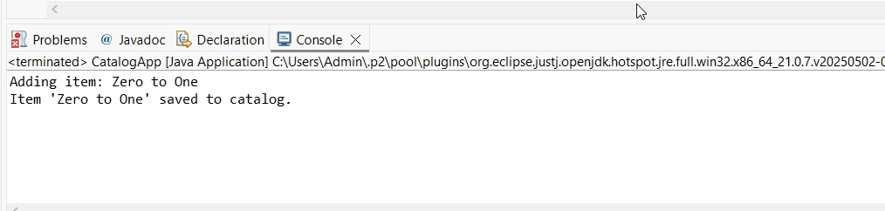

**EXERCISE-4**

